Ecole Centrale de Lyon – Car n°281

Design Report

# Design overview

**Figure 1 :** Valkyriz

Valkyriz is the brand new electric car of the French Team *Ecurie Piston Sport Auto - EPSA*. For its first electric car, the team decided to design and build a vehicle to pass the Scrutineering and finish the Endurance Event with a reasonable budget. Moreover, the aim is to achieve the Acceleration in 4,3 sec and the SkidPad in 5,3 sec. The car may satisfy an amateur driver and obtain a good ranking in the Formula Student competitions.

The main design guideline is to deliver a safe and **reliable** vehicle. That is why the whole car complexity has been limited and also why as many components as possible have been bought as long as they were compliant with the performance objectives. Next year, time will be spent on checking and validating systems before assembly. In particular, the team specially conceived a powertrain testbench to ensure its robustness.

The car is based on a tubular steel space-frame chassis, powered by an axial flux synchronous permanent magnet electric motor combined with 13” tyres without aerodynamic features. The vehicle currently weighs **217** kg.

The team uses the V-model to structure the design, integration and testing of its vehicle. Starting from general requirements, time expectations for dynamic events and according to Formula Student Germany (FSG) rules, the team developed the specifications for each system and then each subsystem. Once the architecture choices were made, the CAD of each part was realised while checking their manufacturability and ease of integration. Today, the detailed design is completed for most systems. As expected, Low Voltage systems and the Tractive System Accumulator need some iterations.

After the design phase, production and supply will be launched as soon as possible in order to keep time for unitary validation of each part. This will be followed by the integration and validation of the subsystems. The powertrain will be then validated and optimised on the testbench. Finally, during the testing phase on track, drivers will train and the team will tune the vehicle in order to maximise grip, make the vehicle easier to master and optimise the settings for each dynamic event.

# Vehicle dynamics & suspensions

## Tyre choice

It has been decided to use *Continental C19 205/407 R13* with 13’’ rims. Indeed, at the same price and same grip abilities, they were 20% lighter than others commonly used in Formula Student Competition. Also, 13’’ rims are used and not 10’’ because this solution offers more space for the upright, the brake disc, A-Arms and suspension rod. This way, the team spent more conception time to adapt other systems for an electric powertrain.

## Suspension

The suspension system was designed as a compromise between extracting maximum possible grip of tyres and being adapted to provide non-professional drivers the best control of the vehicle.

Firstly, a non parallel and unequal A-Arm architecture was designed through 2D and 3D softwares.Thanks to this architecture, it was possible to get both the expected camber variation in corners and the limited and coordinated movements of the roll centers. The A-Arms are made of carbon composite tubes with aluminium bearing housings glued on either end. Carbon tubes were chosen due to their significantly lower weight compared to metal tubes. The gluing of the bearing housings to the tubes requires particular attention, as its strength is critical to safety but difficult to measure non-destructively. Destructive testing is carried out on parts produced simultaneously to the actual A-Arms in order to validate this process.

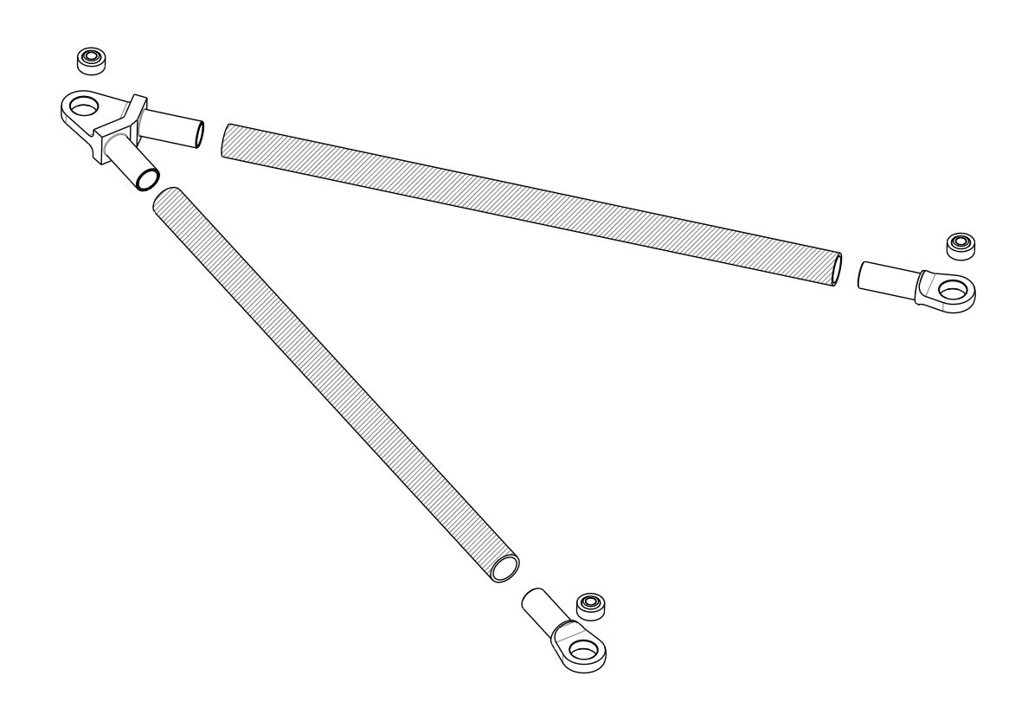To get a compact and well-integrated design in the tubular frame the team positioned the absorber assembly perpendicular to the chassis longitudinal axis, and the push rods and dampers in the rocker plan, which also prevent compliances. Thanks to this solution, reliability was ensured with few resources, as the team was structured to give priorities to electrical systems. Furthermore, this solution provided linear behaviour which is required to simplify calculations, get a great driving feel and a good driver control. To respect the travel course and to have the possibility to make settings, 4-way dampers *Öhlins TTX25 mkII* are used. Finally, the springs have been chosen with ride frequency targets. Next year, adjustments will be made during testing sessions to satisfy general driver style.

**Figure 2 :** Exploded view of the front lower A-Arm

Concerning the anti-roll system, one U-bar system was chosen for its easier integration to the front of the car. Roll centre heights and total roll stiffness were calculated to counteract natural oversteering behaviour of the car. Indeed for non-professional drivers, it’s easier to react to understeer. The stiffness is adjustable by changing the blade length in order to change the vehicle’s behaviour towards oversteer or understeer.

After the car’s production, when it is tested on track, the suspension system will be set in order to correct approximations of the modelling and to give the best behaviour for drivers.

## Steering system

The steering system has to meet several constraints. For ergonomics and proper feeling of the car, load cases are used in the design of the steering pivot to minimise strain at the steering wheel. Caster angle and caster trail are specifically chosen to lower the torque and thus reduce the driver’s muscular fatigue.

Moreover, special attention was paid to reduce freeplay. The team determined the main weakness of the system and strengthened it by using a *Narcco* Rack and a rigid link between the rack and the column.

For performance, lateral grip was maximised using a constant turn model which calculates the optimum slip angles depending on vertical loads. Then, the parallel steering system offers the best compromise between design complexity and grip. A minimum turning radius of 2.25m is respected by adjusting the lever arm between the kingpin axis and the steer arm in the wheel using simple 2D models, the collisions are also considered using the moving 3D CAD.

## Wheels Assembly

The main components of the wheel assembly are the upright and the hub. The hub is bolted directly to the wheel rims, and linked to the upright by angled roller bearings. The bearing reference chosen was carried over from last season, as calculations show that it should withstand the new load cases.

The uprights are designed in order to minimise their mass (which is unsprang, and therefore disproportionately affects performance), given the positions of the suspension mounting points. These points can be tweaked in order to ease the design of the wheel assembly, but are largely determined by the chosen vehicle dynamics. The team paid attention to reducing the number of cuts necessary in the machining process. Edge fillet radius were standardised to simplify manufacturing as well. Lastly, care is taken to minimise part count, for instance by integrating mounting points into the upright body instead of using bolted brackets.

## Brake system

The components of the brake system were chosen to set the brake distribution corresponding to the weight distribution and braking performance target. Then, smaller rear brake discs combined with a large range of settings on the balance bar allow the vehicle to reach its braking objectives. Braking components which respect the specifications are available on the market at a reasonable cost. They offer more reliability than components the team could develop. So it has been decided to buy these components which are critical for the driver’s safety.

# Frame & Body

## Ergonomics

Even though you have a well-engineered vehicle dynamics,if the driver does not feel comfortable or safe, the performance will shrink. This is why the team focused on ergonomics.

A fast-wooden prototype of the cockpit has been created in scale 1:1 in order to determine the position of the driver in the frame. Several drivers of the team had been asked to get into an ergonomic bench and use their perception and feedback to determine the tilt of the seat and the positioning of both the steering wheel and the pedal assy. Furthermore, harness points were chosen in order to avoid constriction or choking..

Finally, the pedals have been designed to provide good feedback to the driver, thanks to their feelings on the way the pedal box should be designed. The current concept allows quick adjustment for the pedal ratio of the brake pedal, the angle range of the throttle pedal and the depth of both pedals.

## Frame

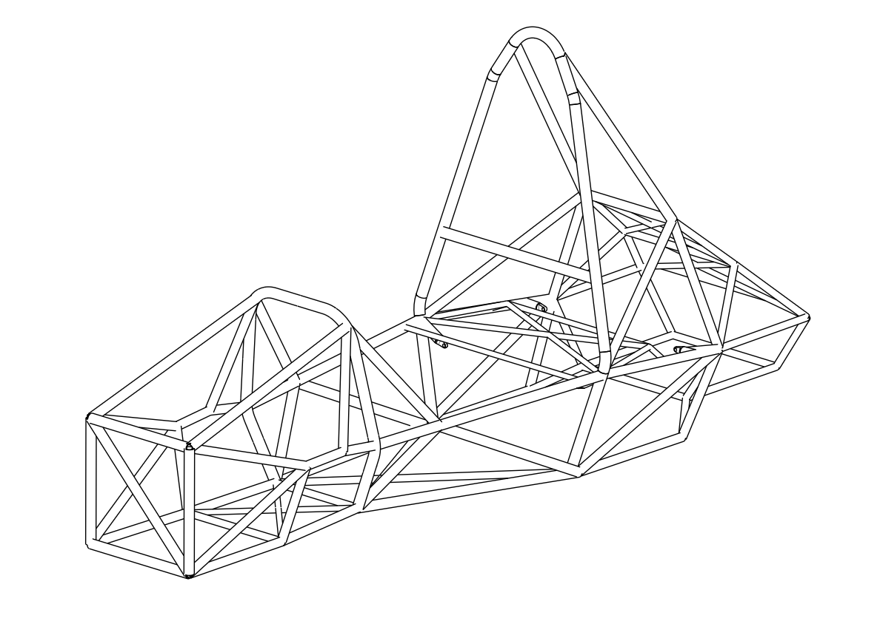To ensure weldability and strength, the tubular structure is designed in 25CrMo4 steel with diameters going from 15mm to 30mm and width being either 1,5mm or 2mm. Frame designers particularly focused on increasing the stiffness/mass ratio, while securing proper implementation of all subsystems of the car. The main objective of the frame was to give supportive points for the suspensions. Also, the frame was designed in order to enhance the driver’s comfort, thanks to the ergonomic wood bench. Frame dimensions were created using adjustable parameters in order to quickly adapt to the evolution of other systems, especially the engine, the battery and suspension mounting points, as well as the driver’s position.

**Figure 3:** Steel space chassis of the vehicle

The frame was analysed using finite element analysis in order to optimise the tubular structure. The expected mechanical behaviour will be verified with physical tests afterwards.

## Body

The main objective of the body is to have an aesthetic car and to show the sponsors without hindering the overall vehicle cost. Glass fibre is used because it is cheaper than carbon fibre, and the weight difference was not big enough to overcome the budget difference. Carbon fibre was 50% more expensive than glass fibre, and only around 23% lighter. Glass fibre side plates over the side impact structure were also used to easily work the side impact structure while guaranteeing to gain some weight and aesthetic.

# Engine and Powertrain

## Engine

For this first year in the electric competition, the priority was to get the safest engine possible, robust and above all reliable. In order to choose the correct engine, the team began by using OptimumLap to identify the power, torque and maximum speed that respect the FSG rules and fulfill the time objectives (4,3 sec) for the acceleration event. It was also important to find a compact component for an easy integration into the vehicle. Finally, the choice fell on the synchronous engine with permanent magnet *EMRAX 228.* Then, the engine was placed just behind the battery pack, above the rear axle with the objectives of minimizing the wheelbase, making the battery’s extraction easier and facilitating the High Voltage Wiring.

## Drivetrain

Firstly, the final ratio guarantees to reach the time requirement for the acceleration event and finish the endurance reducing the output power of the battery during it.

Thus, it was possible to choose either a belt or a chain transmission. Because the main objective is reliability, the choice fell on a chain transmission : it has better efficiency, a longer life service and needs less maintenance. Moreover, it was not possible to use a gear transmission because the centre distance between the motor and the wheel axle is too long, thus making it too heavy.

Because of the peak torque of the engine (230N.m), the differential and the engine were linked in order to reduce stress on the tubular frame. Chain tension is adjusted using two eccentric discs which allow the whole differential to move longitudinally.

## Cooling system

Regarding the cooling system, both the engine and the inverter operating temperature ranges are matching. That is why the team went for a single-loop cooling circuit instead of a double-loop circuit. This option allows a significant weight gain without drifting away from the objective of reliability.

The main part of this sub-system is the radiator which has been designed thanks to the epsilon-NTU method that gives the theoretical thermal power dissipated by a given dimension of a radiator. The choice was made to aim for dissipating the thermal power corresponding to the power peak of the engine (~8kW) and not just the continuous power to design a reliable system. The pressure drop in the engine is finally minimised through its waterflow and therefore the water pump.

## Powertrain test bench

The team decided to design a test bench in order to validate the main components of the powertrain. The battery pack will be validated by an external company to limit safety issues. Then, the motor and its inverter, the electronics and in particular the Vehicle Control Unit will be validated on this bench. In a nutshell, all the system until the engine outlet shall be bench tested.

The objective is to make sure that all electrical systems work before their mounting inside the vehicle in order to guarantee reliability. Moreover, such a test bench shall allow the team to train on new technologies in a safer environment than the vehicle could ever be. Finally, it will in a second time become the way to optimise the performance of the powertrain as well

This year, the main objective is to check that all the components are able to sustain the most challenging loads, whether they correspond to intense peak uses (Acceleration Event) or long runs (Endurance Event). Hence, it will be possible to ensure robustness of the car.

# Electrical

## Electronic

The electrical system is organised around the Vehicle Control Unit (VCU) based itself on a teensy card, that is a programmable electronic development board with microcontroller. Indeed, the teensyduino software is user-friendly and makes the control and the communication between the following elements easier :

* A controller suitable for *EMRAX* motors and working at the operating voltage of the DC battery : the *BAMOCAR D3* servo amplifier. It is also user-friendly as it manages the motor torque in order to meet the VCU command. It communicates with the VCU via CAN protocol.
* The BMS of the TS accumulator and a DC-DC converter to power the low voltage system. Both systems communicate with the VCU via CAN.

Furthermore, to guarantee reliability, some functions are performed by alternative systems instead of the VCU. For instance, the front electronic card made with a teensy card displays only necessary information to the driver such as the State of Charge and the TS accumulator temperature.

To ensure a safe transmission of the information two CAN buses are used: one between the BAMOCAR D3 amplifier servo-motor and the VCU ; the second one between the VCU and the other systems.

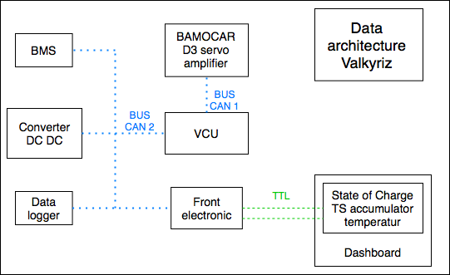

**Figure 4** **:** Data architecture on the vehicle

## Electrical Harness

All the wires have been sized to be as easily mountable as possible : lowest bending radius possible while taking into account the maximum current and the maximum voltage. All electrical elements are fuse-protected and follow standards for vibration and protection against the environment.

Once the Electrical harness was done on paper, the team designed a 3D model of it by finding a correct path for the harness that fits with the bending radius of the wires. The arrangement of the rear unit was developed in order to maximise the compactness while being easily mountable.

Currently, the team does not know how the HV wires are going to behave and how they are going to twist in reality. The next step is to realise a wood model of the rear unit of the car in order to determine if the arrangement could be mountable and could respect the FS rules.

## Battery Pack

In order to ensure that the design of the battery pack is safe, it has been decided to buy an existing component. In this way, it is possible to decrease the amount of risks in terms of conception and manufacturing is clearly decreased. In particular, both BMS and cells will be the references provided by the supplier. Then, simulations on Matlab were made in order to calculate the amount of energy required to finish the Endurance Event. The characteristics of the motor and the Formula Student Rules also helped to finally determine the architecture of the battery : *120s2p*, divided into 5 modules of *24s2p*. Finally, the chosen battery has a nominal voltage of 444 VDC and a continuous current of 125A for a capacity of 7.28kWh.

The whole battery should be tested in a specialised company, which is able to realise verifications in a secured environment. During these tests, the team would like to measure the real characteristics of the battery and check the behaviour of the different components. Two particular points will be the center of the attention of the team. The first one is the evolution of operating voltage and state of charge. With these data, it will be possible to adjust the strategy to deliver and limit power during long runs, such as the Endurance Event. The second is thermal behaviour and in particular the efficiency of the cooling system. To guarantee the security and reliability of the car, high discharge currents and long runs will be studied.